Mystery at the Wildlife Preserve: Multispectral Imagery

**Examining the Health of Fauna through NDVI and Landsat Images**

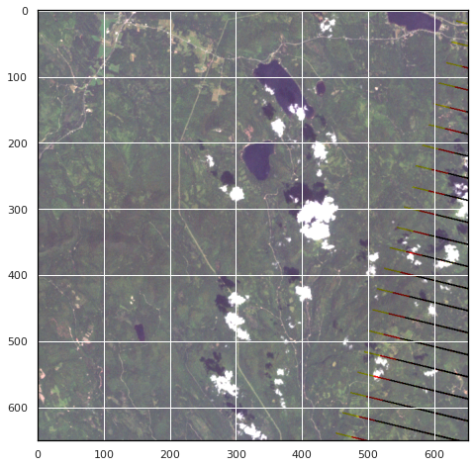

Paul Gagliardi – University of Denver Data Science Captstone Project

6/1/2022

## Introduction

Mistford is a mid-size city is located to the southwest of a large nature preserve. The Rose-crested Blue Pipit is a bird whose life in the wildlife preserve may be under threat, as the local college has noticed signs that the number of nesting paris are decreasing. A student has contacted us to examine some satellite imaging data and try to discern what could be impacting the fauna.

The data examined in this is all Multispectral Landsat imaging over three years in the wildlife preserve and requires some packages and training to use. This study will use combinations of multispectral bands in data mining and visual analysis to come to a conclusion about changes in the landscape that could be affecting the Rose-crested Blue Pipit.

## Dataset Information

There are 12 distinct datasets provided for this project with each set in two forms, CSV and TIF. While these file formats are significantly different, they essentially contain the same data, so they can be used interchangeably with the only distinction being ease of access to the programmer. There are four images a year with three years of data, with the images roughly lining up seasonally meaning three per season. For the vast majority of this analysis, images were only compared among seasons so as to avoid changes in the environment that occur naturally.

### Landsat Data and Multispectral Images

Before diving into the format of the data, it is important to discuss the nature of multispectral imaging, Landsat images, and TIF files.

According to the [USGS](https://www.usgs.gov/faqs/what-landsat-satellite-program-and-why-it-important), “The Landsat Program is a series of Earth-observing satellite missions jointly managed by NASA and the U.S. Geological Survey.” These satellites use cameras or sensors to get multispectral imaging data on sections of Earth they pass over. Though the data in this is provided via a zip folder rather than direct download from a Landsat database, the TIF files have the same format and methods of handling as standard Landsat files. The satellites that create these images have “the optimal ground resolution and spectral bands to efficiently track land use and to document land change due to climate change, urbanization, drought, wildfire, biomass changes (carbon assessments), and a host of other natural and human-caused changes”, making them perfect for this analysis (USGS). These Landsat files are made up of pixels that when combined form an image, and each pixel has 3 or more multispectral band values.

Multispectral Data is any data that represents image data of multiple wavelengths of light. Outside of visible light, there is UV, infrared, radio, etc. In this analysis we get 6 “spectral bands” or wavelengths of electromagnetic radiation, and we can use several combinations of them to try to discern usable insights. Provided by a document that came alongside the Dataset, the bands in the dataset are as follows:

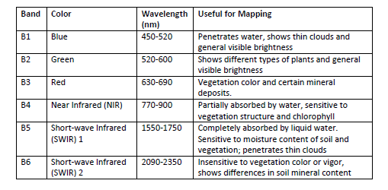

Other Landsat files have varying amounts and types of bands, such as offering UV or Ultrablue which this dataset does not.

Band combinations are highly useful as well when plotting a multispectral image. A well-known band combination is RGB, which will produce a true color image. Some other combinations used in place of RBG when stacking bands for an image can provide other insight, creating false color images that still convey pertinent information. The ones possible in this analysis are as such:

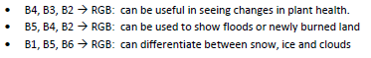

Images can also be represented by a single band, providing a single value for every pixel, and employing mathematical formulas on the bands can result in useful single pixel values. In this study we use NDVI (Normalized Difference Vegetation Index). This is highly useful for distinguishing between healthy, moderate, low, or no vegetation. It is calculated using Red and NIR light.



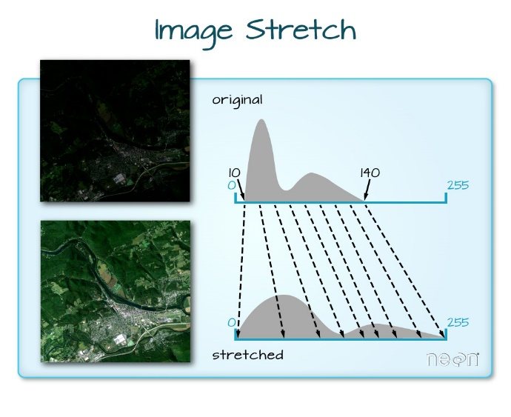Lastly but still of note, often due to conditions in the environment such as clouds, snow, glare, sun level, time of day, or anything else that effects light or resolution for the satellite the images can look very different even among the same bands. It is important to take these factors into account. Stretching images is one of the ways to do so, as it can artificially brighten or dim an image to normalize its appearance. This project does not have dynamic stretching, but rather applied a general stretch on the RGB images to help highlight features (image via [www.earthdatascience.org](http://www.earthdatascience.org))

### TIFs

TIFs are the standard file format used for Landsat data, but additionally have several other applications and are widely used by graphical artists and photographers as they are a high-quality graphics format. TIF stands for Tagged Image File, and each TIF file can have several different “layers”. This makes them especially useful for multispectral imaging, as each layer can represent a multispectral band.

TIFs will consist of array of size (B, X, Y). B will represent the number of layers on the images, or in this case spectral bands. X and Y represent the coordinates of the band values in the data, with each point representing a pixel. These pixels combine when plotted to show a full image at each band value.

TIFs are much larger than JPEGS and are losses meaning that they will never lose pixel quality due to editing.

### Features

While the TIF data is a bit more complex, surveying the form of the CSV data will give a good understanding of the information in both. The CSV when imported looks like a standard Dataframe with the following columns:

* X: X coordinate of Pixel
  + Min 0, Max 651
* Y: Y coordinate of Pixel
  + Min 0, Max 651
* B1:Blue intensity
* B2:Green intensity
* B3:Red intensity
* B4:NIR intensity
* B5:Short-wave IR intensity
* B6:Short-wave IR intensity

All bands are in form uint8, meaning they range 0 through 255.

These Datasets are large, with each of the 12 having 423,801 rows representing a 651 by 651 pixel image, and with 6 values for each pixel.

The TIFs are in array format once unpacked in shape (6, 651, 651), but contain the exact same amount of information. TIFs are generally a bit easier to use once put in the proper format and using the right packages to access, so most of the analysis was with these files.

## Data Exploration & Visualization

### Exploration and Cleaning

When first examining the data, it is useful to use a true color examination of the images to get an initial system wide snapshot. Here are those images representing the picture chronologically (stretch factor of 0.6 applied).

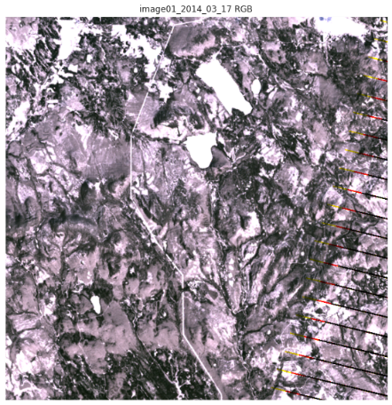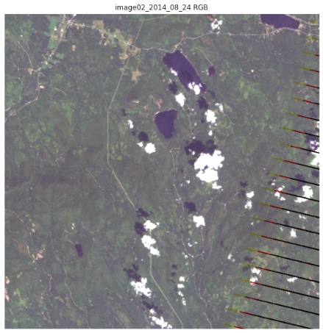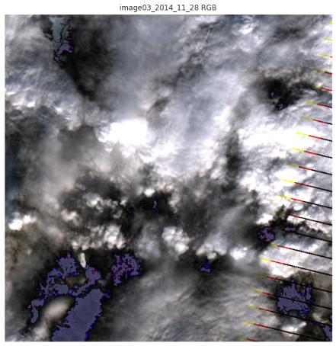

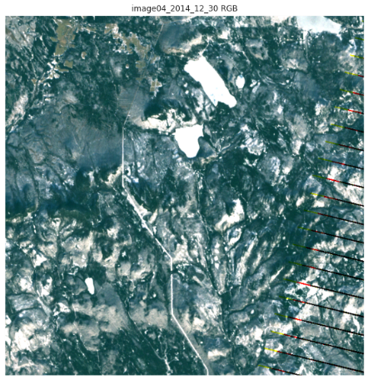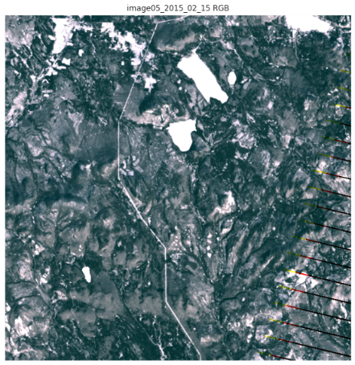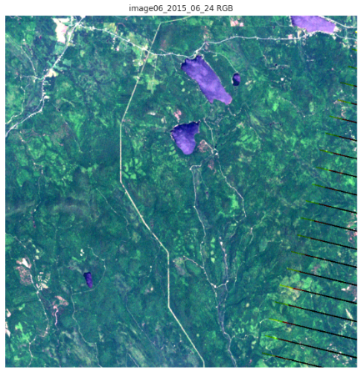

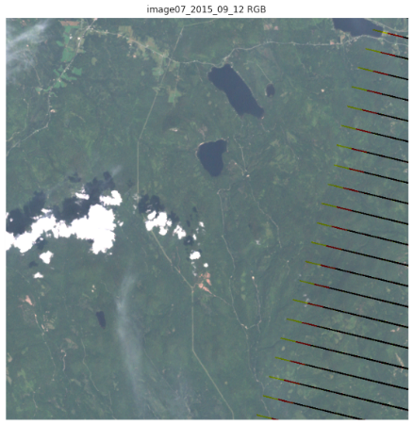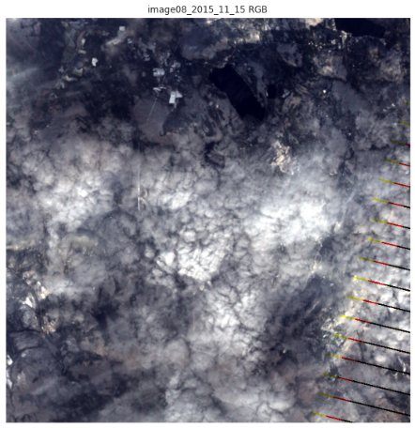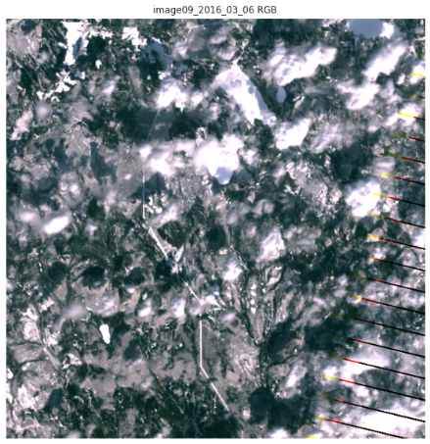

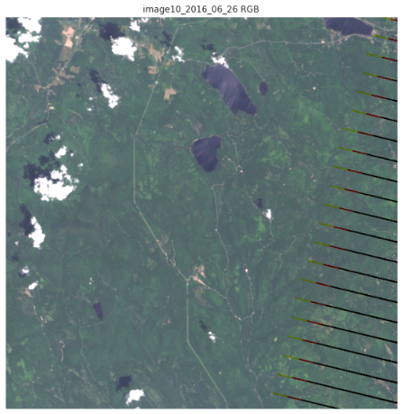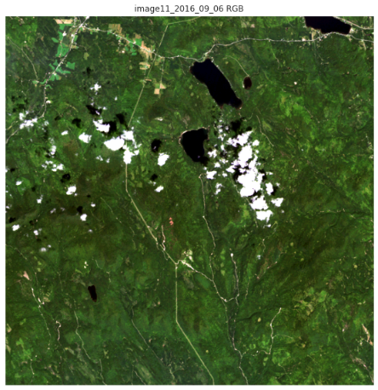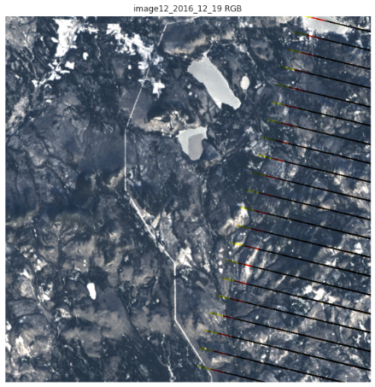

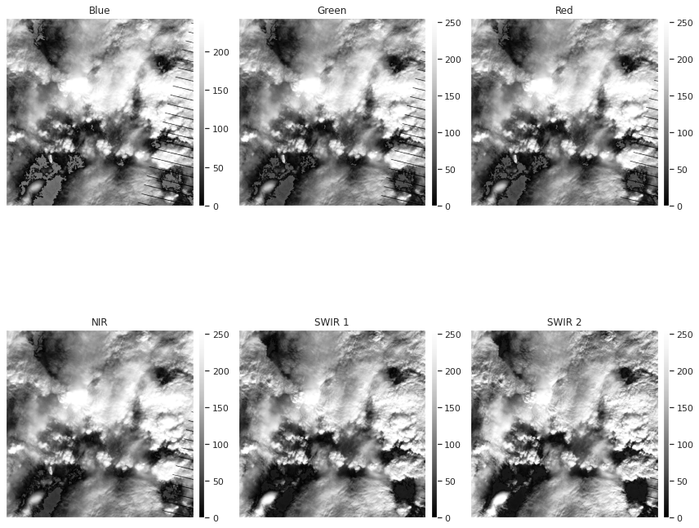Image 3 and 8 show heavy cloud cover for the RGB visible light images, but it is possible they could be useful to us for other wavelengths. To test this, plotting greyscale images for each band would show the utility of each band.

Image 3:

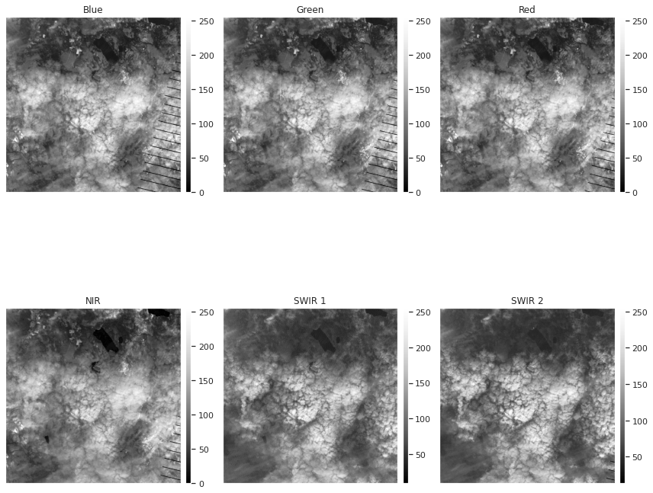 Image 8:

This shows very heavy cloud cover across all bands, so these images will be removed from further analysis.

As stated above, the seasonality of these images is highly important, so the remainder of the analysis will be only examining one season at a time or only one season total for certain bands. Here is the breakout:

* Spring
  + Image 1 – 03/12/2014
  + Image 5 – 02/15/2015
  + Image 9 – 03/06/2016
* Summer
  + Image 2 – 08/24/2014
  + Image 6 – 06/24/2015
  + Image 10 – 06/26/2016
* Fall/Autumn
  + Image 7 – 09/12/2015
  + Image 11 – 09/06/2016
* Winter
  + Image 4 – 12/30/2014
  + Image 12 – 12/19/2016

Though image 5 is technically in winter, it is less than a month away from the other Spring images and is closest to them in terms of time of year. These Spring images also provide some of the clearer snapshots of territory and are closer in date compared the three summer images, so much of the comparative analysis both qualitative and quantitative will rely on them.

## Data Analysis

### CIR Analysis

CIR is one of the false-color bands discussed above that provides insight beyond RGB. This uses bands B4 (Near Infrared), B3 (Red), B2 (Green) in place of RGB. This combination is useful for seeing changes in plant health as plants reflect NIR and green while absorbing red. Typically this indicates that images with more red have more vegetation. Looking at the spring images, we actually see some growth in red coloring suggesting a growth in vegetation.

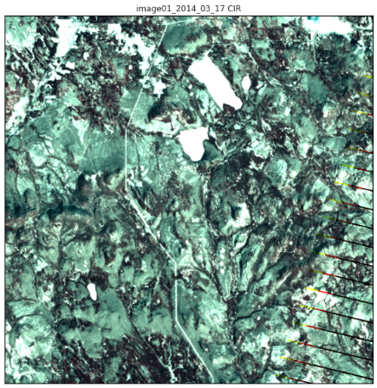 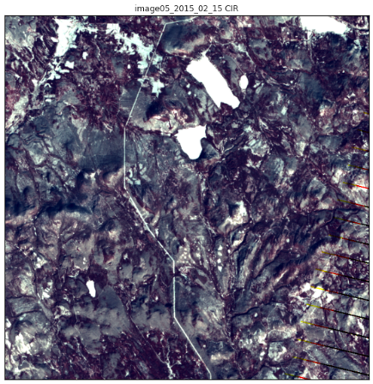 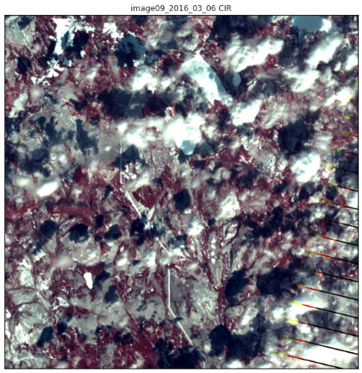

Looking at the true color images of these, these is a noticeable discrepancy in the tone and general shading of these images, specifically in the first one which is much more grey than the other spring pictures, and since these images use **two** visible light bands this could be impacting the visualization of these images. Further analysis is needed.

### Flood/Water Analysis

Another useful band, as described in the Dataset Information session, combines B5 (SWIR1), B4 (NIR), and B2 (Green) is useful for seeing not just water, but also soil or ground with high water content. This can therefore be used highlight floods or newly burned land. Examining the Spring images we see this:

We can clearly see the lakes that are visible in the true color images, as they show up as a turquoise/teal color. Additionally, we can see high amounts of teal in the left corner among all images which we will talk about later.

Mostly this analysis is useful to point out that in the 2016 image, there is a significantly higher level of teal indicating possible flooding or higher than typical levels of precipitation. This is our first noticeable change that would indicate a possible change in the environment that could impact flora or fauna. Having flooded lowlands could certainly impact the Pipit habitat.

### NDVI Analysis

Using the formula described in the Dataset Information section and a custom function, we can plot the NDVI levels across the images and compare. To make analysis easier, we will be categorizing the NDVI levels into 5 categories. These categories are defined on the EarthPy site [here](https://earthpy.readthedocs.io/en/latest/gallery_vignettes/plot_calculate_classify_ndvi.html) with distinct values, however for this analysis images the values are slightly tweaked to have better clarity and better highlight the differences between the images.

* No Vegetation (-1 < x < -0.25)
* Bare Area (-0.25 < x < 0)
* Low Vegetaion (0 < x < 0.25)
* Moderate Vegetation (0.25 < x < 0.4)
* High Vegetaion (0.4 < x < 1)

Comparing the images for each season year to year shows interesting results. A count of pixels in each category is also provided.

Spring

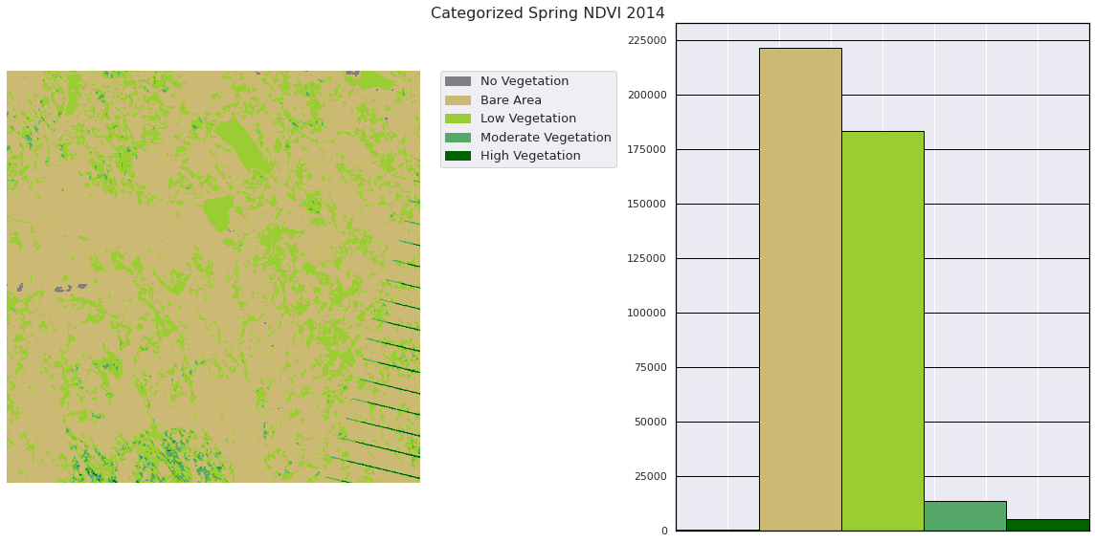

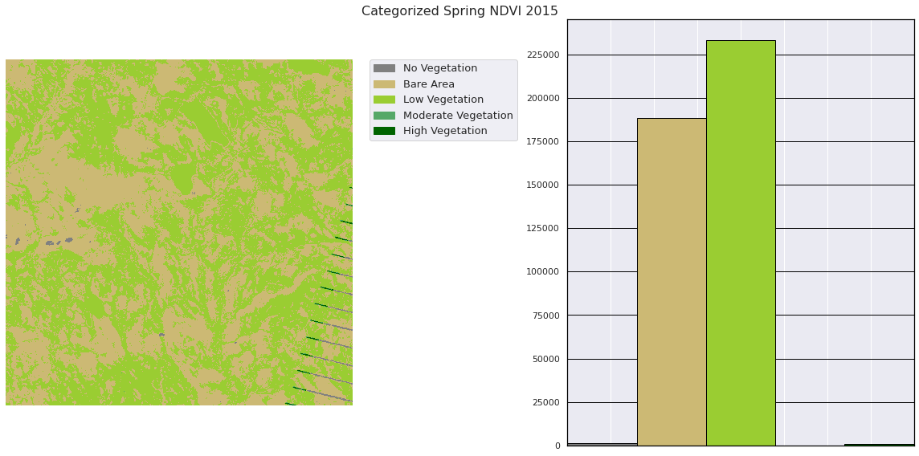

We can see a significant increase in the No Vegetation category, from almost none to roughly 24,000 pixels. Both the first and last images are from March.

*Summer*

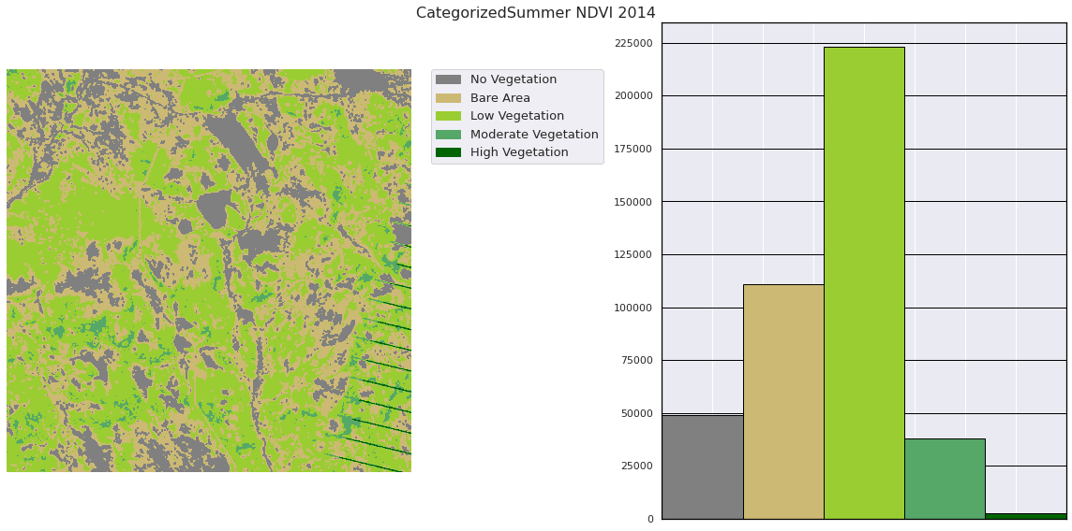

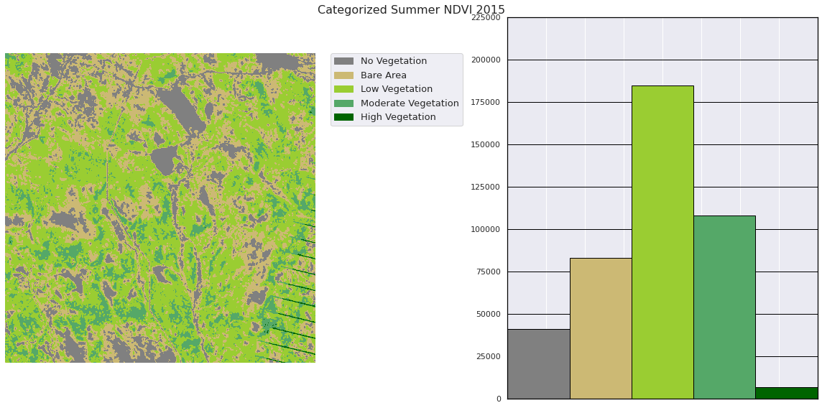

Summertime actually sees an improvement in vegetation from 2014 to 2016; however it is of note that the first image is in August and the Third is in June. The 2015 and 2016 images are both June, and show very little difference in vegetation health.

*Fall*

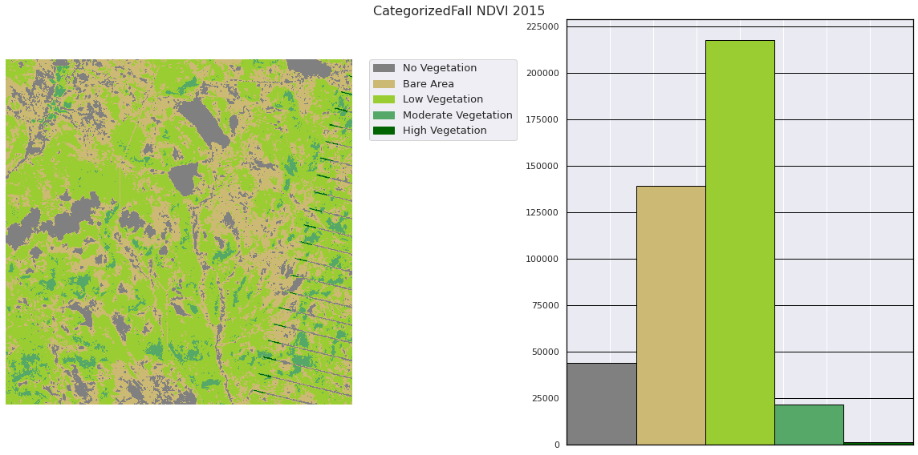

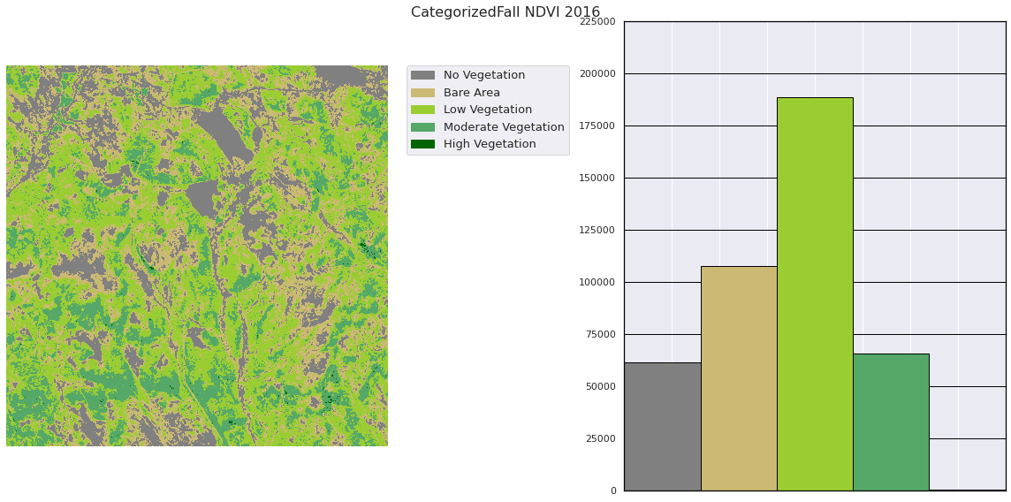

We can see a significant growth in the No Vegetation category from 2015 to 2016. Both images are in September.

*Winter*

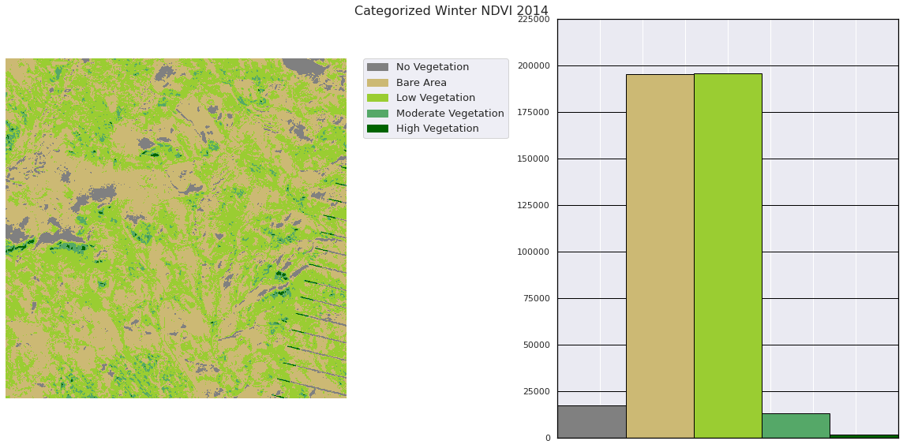

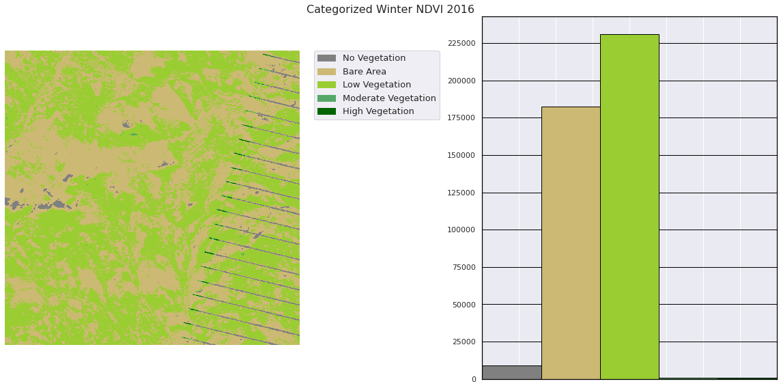

Winter sees a slight growth in overall vegetation (No Vegetation category), but moderate vegetation and high vegetation dropped, Since these images are in Winter, we would normally expect lower vegetation, so these results are fairly inconclusive.

## Feature Identification

An important issue when dealing with Landsat images is to orient oneself to the size of the picture and real world objects within it.

### Image size

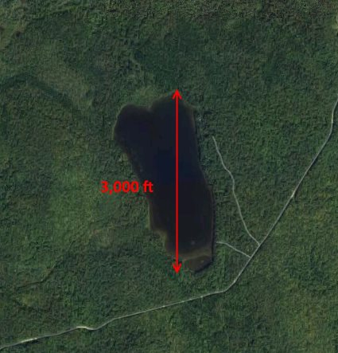With the dataset, an image of Boonsong lake, a lake in the wildlife preserve, is provided. This lake is oriented north south and shows the lake to be 3000 feet long. We can find this lake in the images and use the number of pixels in length to guess the size of the pixels. 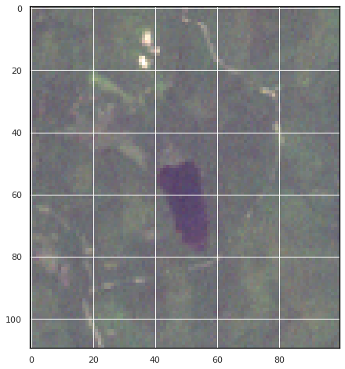

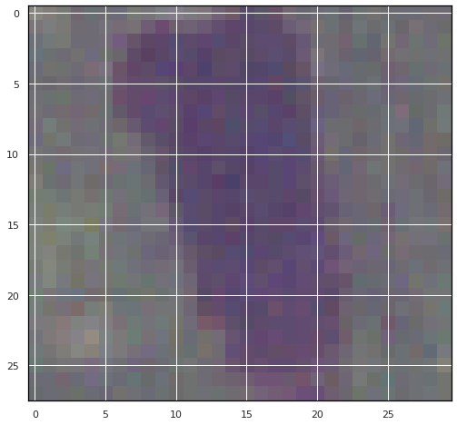We can find the lake in the bottom left corner of the image. Zooming in we can see it is roughly **29 pixels long**. This puts the Pixels at roughly **103.5 feet** in length with the image set in the same orientation.

Extrapolating this a bit, the image is roughly **12.76 by 12.76 miles**, and **162.8** **sq. miles total**. This is comparable to the size of the Denver Metro area at 154.7 Miles.

### Other Image Features

*Town*

In the very top left of the images we can see a L shaped town with a road passing through.

Comparing the Summer August (left) and June (right) images we can see the crop fields are either dead or have not grown yet in June

*Roads and Trails*

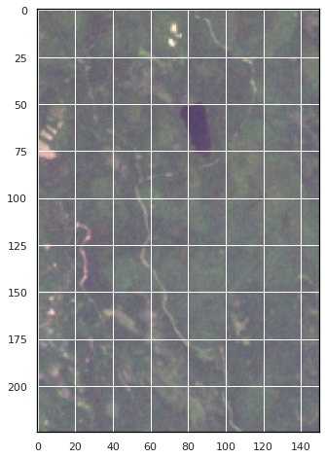 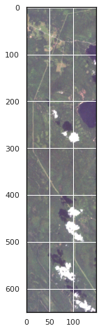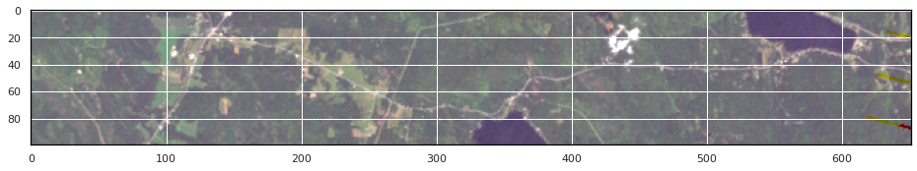

We can see a few roads and trails in the image. One trail runs by Boonsong lake, another (the skinniest image above) shows a main road that runs the length of the image, and we can see a road that goes through the town as well.

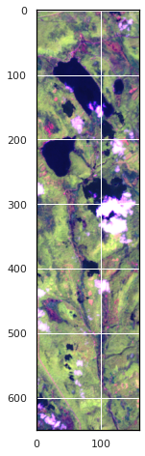*River*

Upon first inspection of the RGB images, it appears that there is a trail running to the large lakes in the top center of the image. However, this is mostly likely a river given it shares the Blue color of the lakes when viewed from the “Flood Bands” discussed in the Flood/Water Analysis. This river links the two large lakes and moves through what is probably a valley in the Mistford Reserve.

*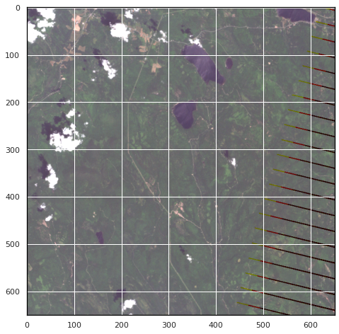Lakes*

We can easily identify the lakes using simple RGB. There appear to be 5 total; Boonsong in the bottom left, the two large lakes flanked by a very small lake to their east, and a partial lake in the top right.

*Irrigation*

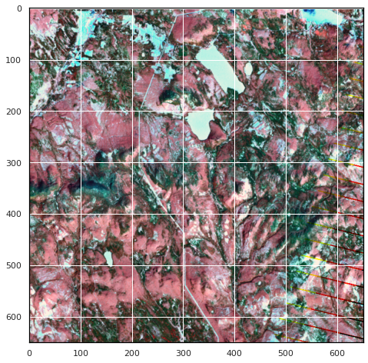Again Utilizing the “Flood Band” we can see around the town in the top left a lot of water content. This is right on top of the crops we identified earlier, so this seems to be an indication of irrigated crops.

## Conclusion and REflections

This analysis could have been improved in several ways that are worth mentioning. Most Landsat images come equipped with a QA layer which can be used to provide a mask for clouds, shadows, and faulty pixels. This data did not, however there are existing (but complex) Data Science techniques that can create these QA layers from just the bands provided. Additionally, the 100 feet pixel size is considered on the medium – low end of Landsat Resolution ([reference](https://eos.com/blog/satellite-data-what-spatial-resolution-is-enough-for-you/)), so a higher resolution image would have provided results that could be more conclusive. Lastly, a systematic machine learning approach to stretching images could have been applied based on the rang of the spectrum that each band spans. This could normalize the images so that tone from light, atmospheric conditions, glare, or anything else that changes the color of the images would have a lower impact on quantitative or qualitative analysis.

There is noticeable vegetation loss when comparing 2 out of 4 seasons which is enough for me to conclude that there are factors in the environment that are impacting the local flora, which in turn would impact the local fauna. Additionally, there seems to be signs of flooding or more precipitation in 2016 which might be impacting the habitat of the Pipit. Overall, the students concern is justified, and the Pipits’ nesting is likely impacted negatively by these environmental factors.

Analysis with more Landsat images or ground level data is needed for a higher certainty on this hypothesis. Getting precipitation information that could be paired with the months of the images would be very useful